Project Design Phase-II
Data Flow Diagram & User Stories

Date | 04 February 2026
Team ID | LTVIP2026TMIDS49772
Project Name | TransLingua: AI-Powered Multi-Language Translator
Maximum Marks | 4 Marks

Data Flow Diagrams:
A Data Flow Diagram (DFD) is a traditional visual representation of the information flows within a system. A neat and clear DFD can depict the right amount of the system requirement graphically. It shows how data enters and leaves the system, what changes the information, and where data is stored.

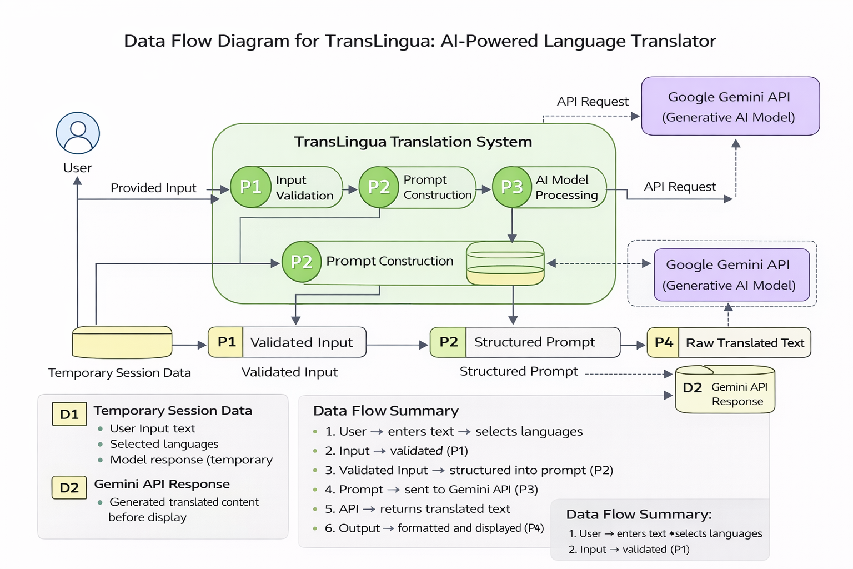

User Stories
Use the below template to list all the user stories for the product.
User Type | Functional Requirement (Epic) | User Story Number | User Story / Task | Acceptance criteria | Priority | Release
Customer (Mobile user) | User Interface Setup | USN-1 | As a user, I can access a Streamlit-based interface to enter text and select source and target languages. | I can enter text and choose languages successfully. | High | Sprint-1
Administrator | Input Validation | USN-2 |  | I receive validation messages for empty or incorrect inputs. | High | Sprint-1
  As a user, I want the system to validate my input text and selected languages before translation.
System | AI Model Integration | USN-3 | As a user, I want the system to translate text using the Google Gemini API. | The system successfully integrates with Gemini and returns translated text. | High | Sprint-2
Administrator |  | USN-4 | As a developer, I want to construct structured prompts to ensure contextual and accurate translation. | Prompts are correctly formatted and produce context-aware translations. | Medium | Sprint-2
  Prompt Engineering
Customer (Mobile user) | Output Display | USN-5 |  | Translated output is displayed in a readable format. | High | Sprint-3
  As a user, I want to view the translated text clearly on the screen.
Customer Care Executive | Deployment | USN-6 | As a developer, I want to deploy the application on Streamlit Cloud so users can access it online. | successfully deployed and accessible via URL. | Medium | Sprint-3

